**Tiger generator report – documentation:**

There are 3 important python files:

PlotSelectionDialog.py

This file has everything related to the UI design.

Plots.py

This file has all the functions that create the different plots.

Create_plot – creates a simple plot and receives those arguments:

* output_plot_path – The path where the plot is saved
* tables – the data. For example I want to create a plot of depth over time. So tables will be = {'depth' : [… the actual data..], 'timestamp' : [….]}
* units_config_path="units_config.json" (json file that has the unit per value).
* Plot = false, if I want to have a line I will send plot = True, otherwise there will be points in the plot.
* Mean_sd = False, if mean_sd = true the mean and standard deviation will be calculated.
* Range = (0,0) , we can set the range of the graph.

All the other functions are work in the same way

Create_mixed_plot will create graph like this:

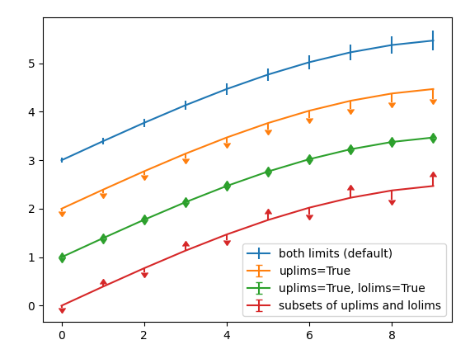

create_partitioned_plot will create graph like this:

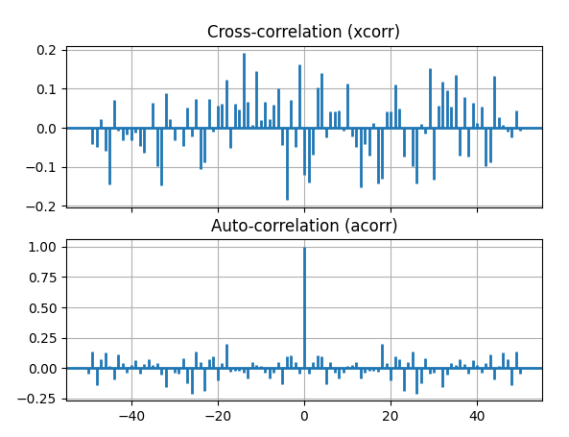

Generate_results.py

This file has the main function. There are cases for all the options that the user chooses, and according to the conditions you choose which graphs to build.

When you want to run the program, you need to run this file.

A window will open where you can choose mat files. (Note: the example mat files are in the following path: C:\Users\LAR-TEAM\Documents\LAR Documents\tigerResultsGenerator\.venv)

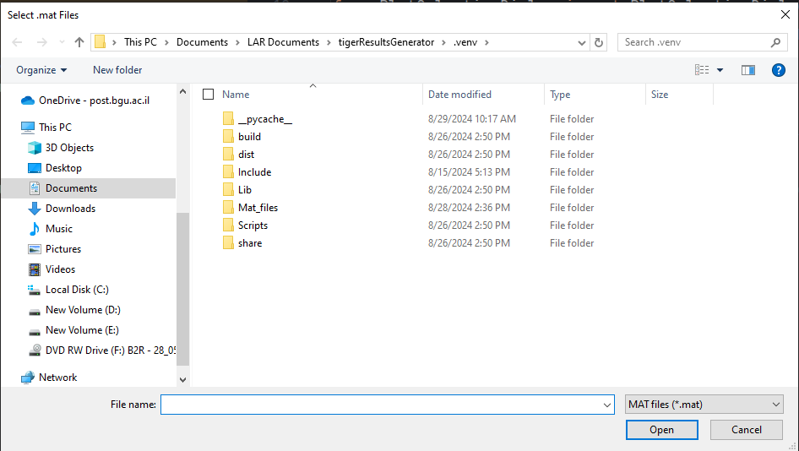

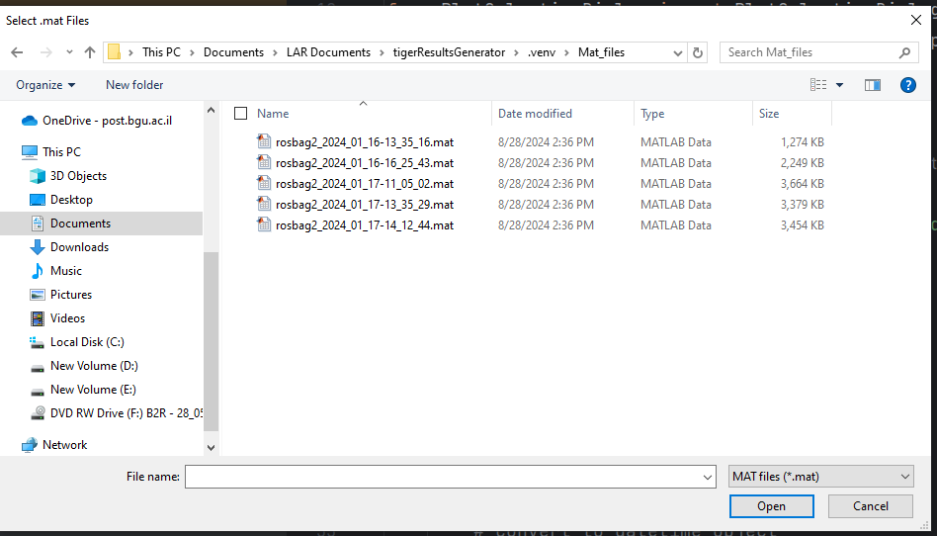

Once you choose, a window will open where you can choose which tables to create for each file:

You can choose different settings for each file and then click "ok" or choose the settings only for the first file and choose "choose same for all" and then click "ok".

Important note: if you want the program to run faster, do not choose "Add a picture of the map"

Now the program will run for several seconds (and maybe will print some comments on the screen)

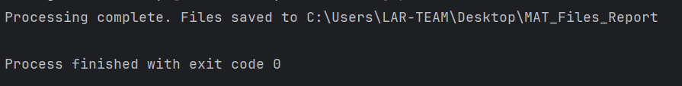

When it finishes you will see a folder that called "MAT_files_report" with all the data on the Desktop.

